Fully Automatic Top Flat Surface Labeling Machine ZRW-113
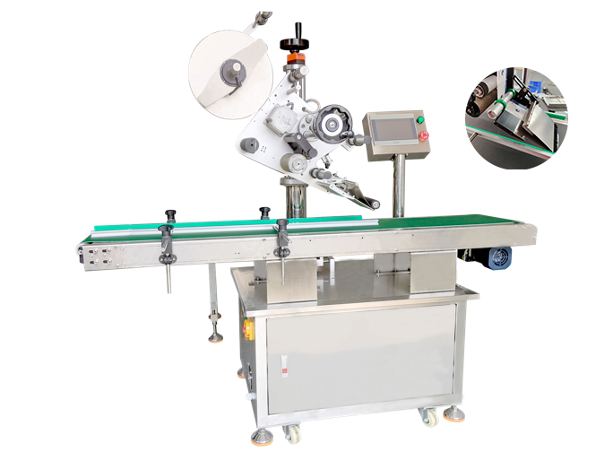
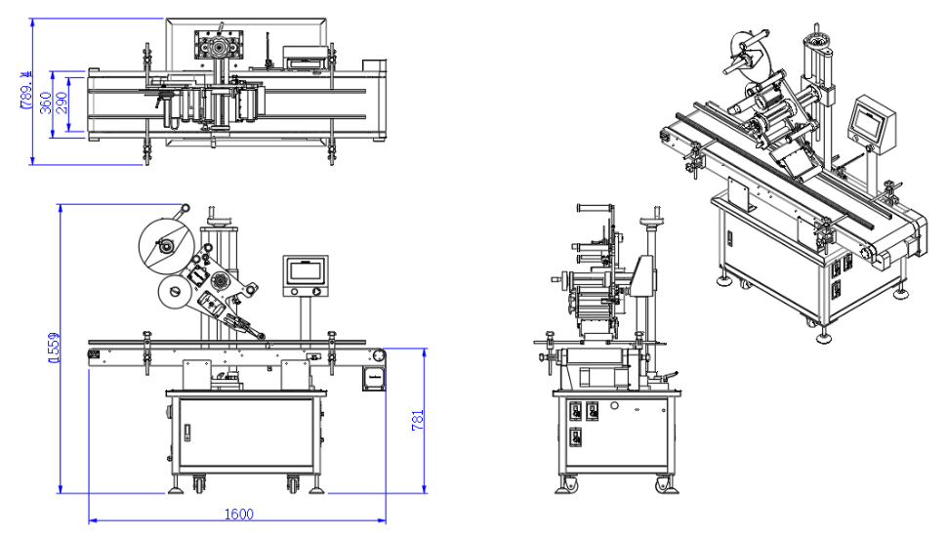
Equipment Layout：
Basic Use：
The automatic plane labeling machine is suitable for labeling or self-adhesive films on the upper plane of various articles, such as books, folders, boxes, cartons, etc. Changing the labeling mechanism can be suitable for labeling uneven surfaces, which is widely used for planar labeling of large products and labeling of planar objects with large specifications.

Equipment Advantages：
- Intelligent touch screen, imported PLC and artificial intelligence realize human-computer interaction
- The labeling mechanism adopts a brush or sponge to make the labeling on the label smoother and ensure the stability of labeling.
- The adjusting seat is equipped according to the characteristics of the sample appearance to ensure that it can be adjusted to a suitable labeling angle.
- Imported German Sike electric eye can accurately detect the label position.

Main technical parameters：
Name/Model | Fully Automatic Top Flat Surface Labeling Machine ZRW-113
L*W*H Scope of application | 400(L)*200(W)*200(H)  （Customized as per sample）
Applicable label scope | L(10～350)mm、W(10-150)mm
Labeling Accuracy | ±1mm（Excluding tolerance from product and label itself）
Packing speed | 约0-80P/min（Subject to product and label dimensions）
Applicable Label Core ID | 76mm
Applicable Label Roll OD | ≤300mm
Power supply | AC200-240V,50-60HZ 200W
Air supply pressure | 5KG
Machine size | 2000(L)*1100(W)*1500(H)mm
Net weight | 150kg

Configuration parameters:
Model | SDW-113  Fully Automatic Top Flat Surface Labeling Machine
（Programmable Logic Controller） | PLC
Label Sensor | SICK
Product Sensor | PLC
Label Belt Clamping Motor | RUIDA, Inverter-driven
Label Head Traction Motor | LEADSHINE
HMI (Human-Machine Interface) | WECON
Conveyor Motor | RUIDA, Inverter-driven
Machine Frame | Stainless Steel, Aluminum Alloy

